The university of Azad Jammu and Kashmir ,
Muzaffarabad

Name | Adeela Bashir
Roll no | 2024-SE-12
Course Title | Computer Networking
Lab | 1
Submitted to | Engr Asma javeid

Department of Software Engineering

Computer Networking
Lab #1
Open chrome and search for cisco Packet Tracer:

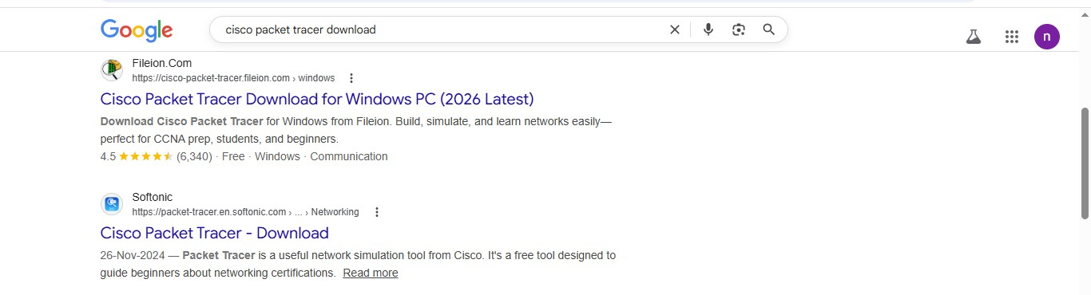
Navigate to download section:
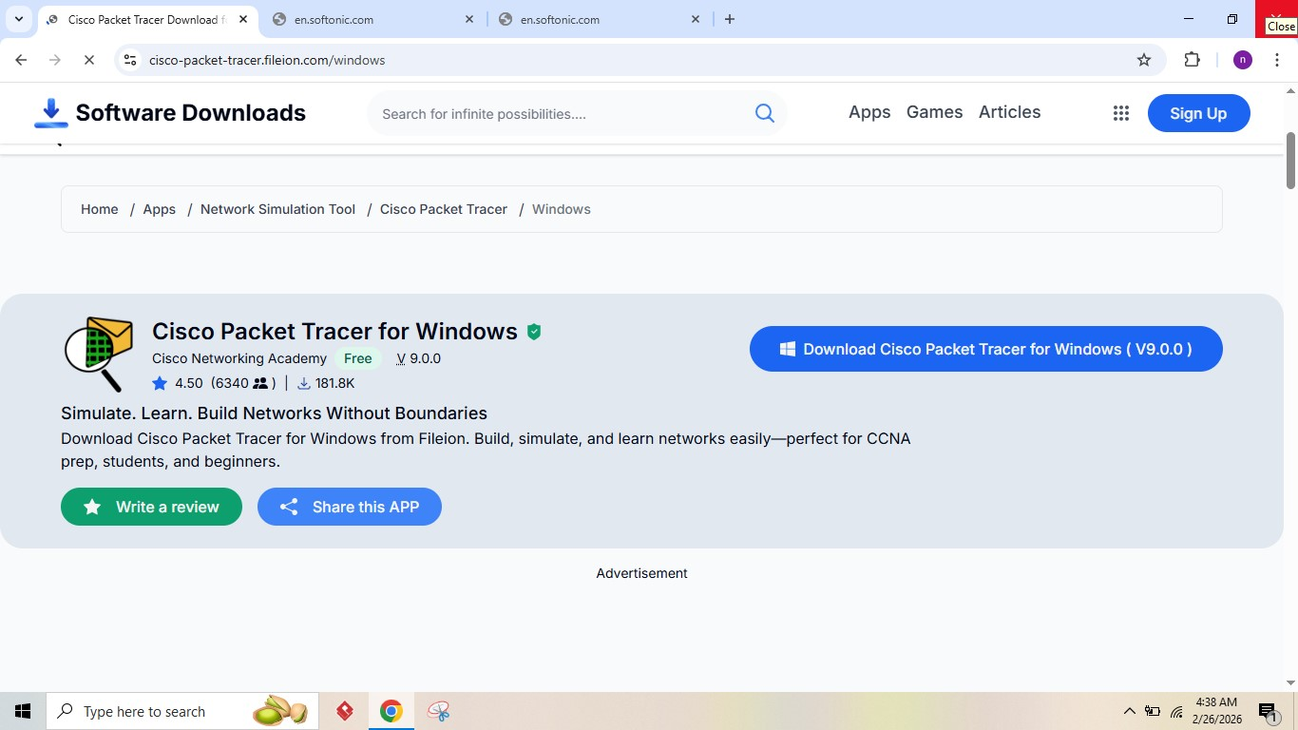
Download packet tracer:

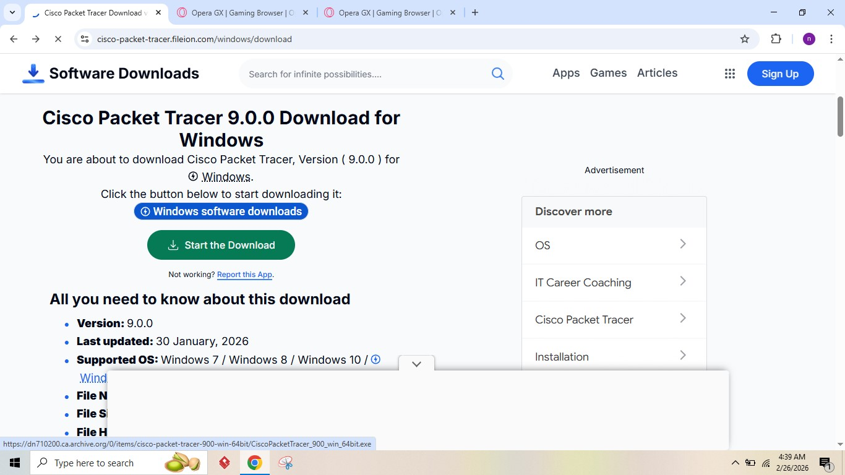

Install packet tracer:

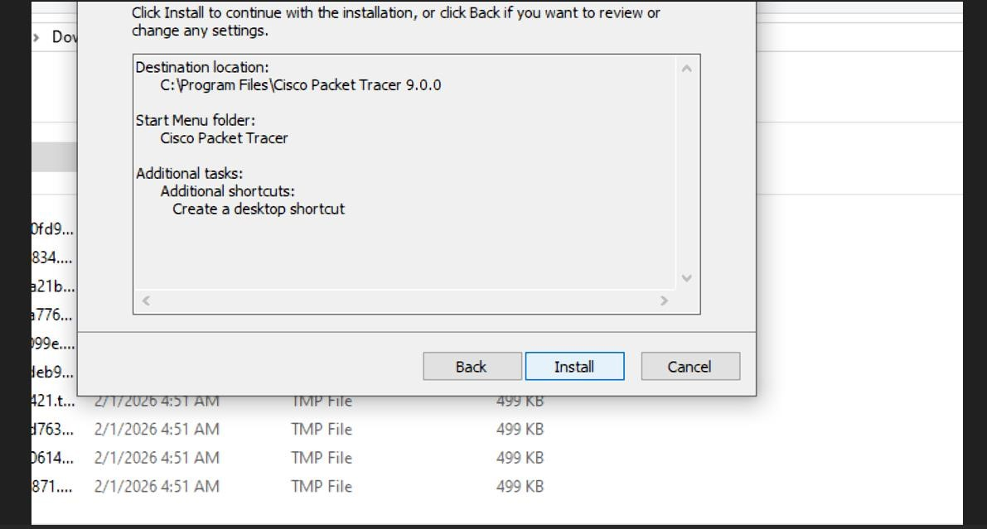
Login in to Cisco account:

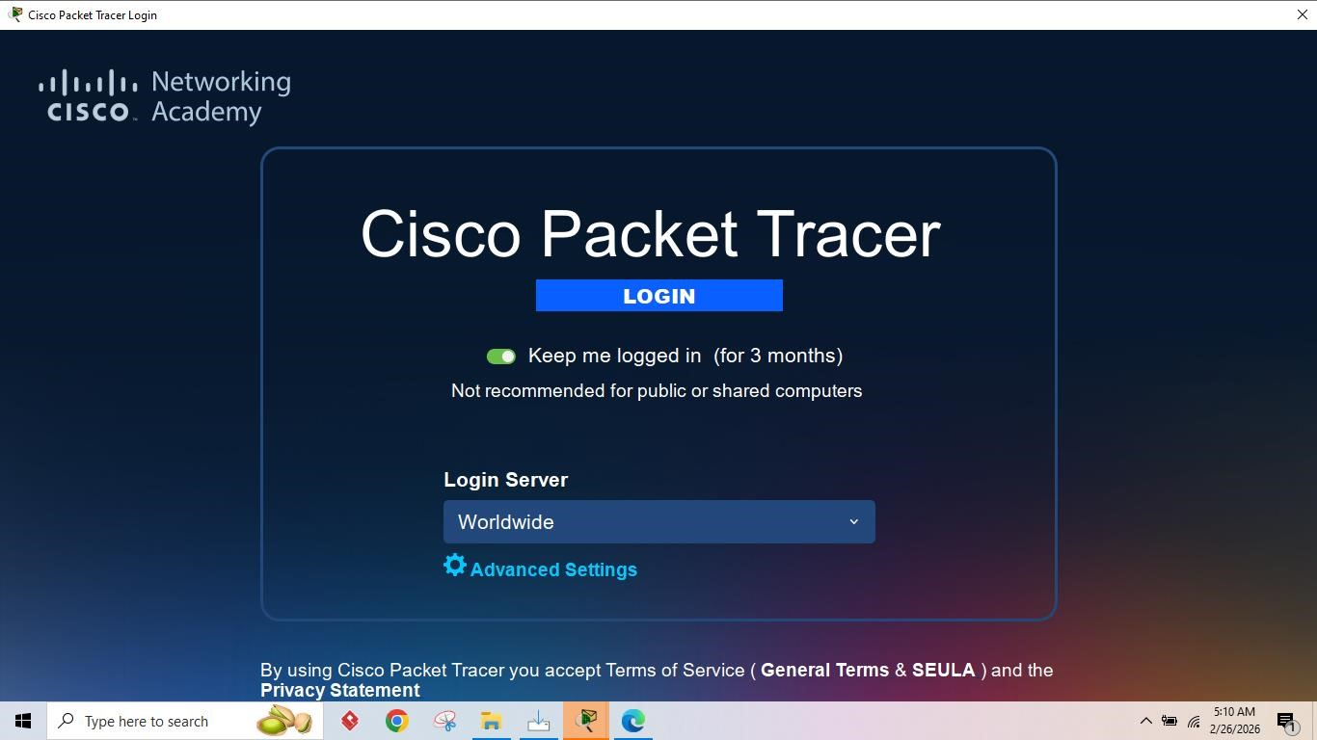

Launch Packet Tracer:
